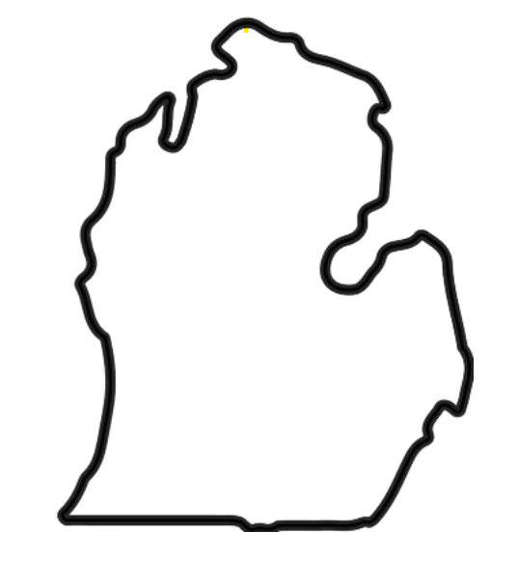

**CLINTON/INGHAM/EATON**

**MACOMB**

**OAKLAND**

**GENESEE**

**SANILAC**

**HURON**

**SAGINAW**

**MIDLAND**

**BAY**