Celebrate DSP week with us! |  |  |  |   September 2026
September 14th – 18th  Monday – Crazy hat/ hair day (the bigger, the better)  Tuesday – Team color day (each shift pick a color)  Wednesday – Decades Day (70s, 80s, 90s throwback)  *Gas giveaway – Staff are welcome to come to designated gas stations from 10a-3p and receive $25 in gas. (A ticket will be given to each staff member with their name printed on it. They MUST bring the ticket to receive the gas.  Thursday – Twin Day match with a coworker  Friday – Superhero Day (because DSPs already are one  All week PC’s will be stopping by with treats for each home. |  |  |  | 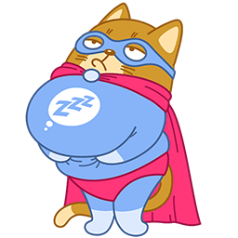


Character Trait Spotlight
This month we are shining our spotlight on Lynda Fath.
Lynda goes above and beyond for all those around her. Her acts of compassion, initiative, and commitment to making a positive impact and meaningful difference

Anniversaries
Shalaia 1 Year
French
Dawn 1 Year
Thayer
Ava 1 Year
Salas
Holly 1 Year
Williams
Christopher 1 Year
Harbin
Cody 2 Years
Winters
Kanquasha 3 Years
Stevenson
Dexter 3 Years
Boyd
Mariyah 4 Years
Barney
Dalisa 4 Years
Redick
Mary 6 Years
Roe
Gregory 6 Years
Ussery
Donna 7 Years
Dennis
Julie 10 Years
Winters
Lisa 19 Years
Pennyman
Marlene 26 Years
Wallace

Hello Everyone, 
September Birthdays

Jonathan | Lokken | 9 | 1
Elijah | Purcell | 9 | 2
Deonna | Kincaid | 9 | 2
Miyah | Smith | 9 | 5
Averiana | Hunter | 9 | 6
Nishyia | Hudson | 9 | 7
Andrea | Stewart | 9 | 7
Carissa | Justin | 9 | 8
Trayshon | Young | 9 | 8
Jalyn | Brown | 9 | 10
Cody | Winters | 9 | 10
Jasmise | Simmons | 9 | 11
TyShydrik | Howard | 9 | 11
Angela | Joseph | 9 | 12
AnnDenise | Owens | 9 | 14
Johana | Rodriguez | 9 | 15
Edith | Bakewell | 9 | 15
Bethany | Kellet | 9 | 17
Jada | Broden | 9 | 18
Sherrie | Kennebrew | 9 | 20
D'Paris | Martin | 9 | 20
Danielle | Munerlyn | 9 | 22
Angel | Preston | 9 | 23
Shelley | Vuillemot | 9 | 24
Karand | Houston | 9 | 25
Tiffany | Stob | 9 | 25
Cora | Jackson | 9 | 25
Christy | Benton-Mayes | 9 | 27
Haley | Garcia | 9 | 29

We are approaching the cozy transition from late summer into fall, golden autumn leaves beginning to replace lush green foliage, warm amber sunlight filtering through the trees.
Reminders & Highlights
Be an active TV watcher. Many people get geared up for fall premieres of their favorite television shows. If you're going to sit down and watch hours of TV. Get moving. Make a date with exercise and TV.
While you watch, you can walk or run in place, do standing lunges, do tricep dips off the couch, or lift weights. During commercials, do push-ups or sit-ups. In a one-hour show, you probably have close to 20 minutes worth of commercial interruption.
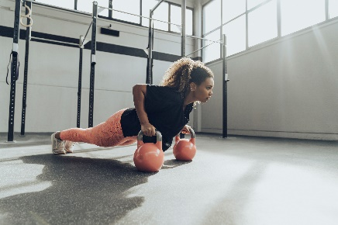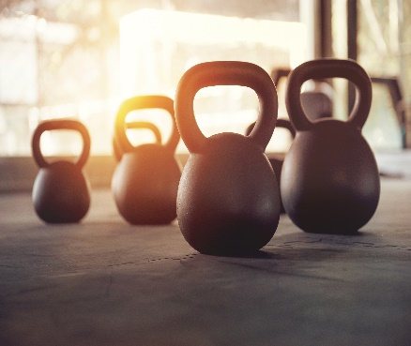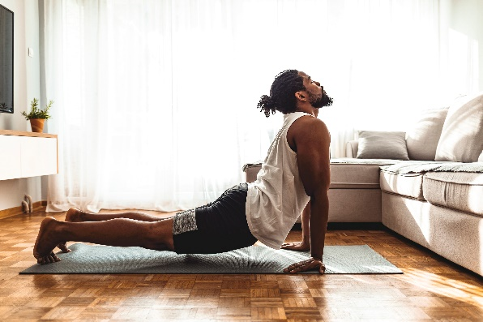
Rejuvenate yourself. Fall is the time to rejuvenate body, mind and spirit. Get a massage after your run. Learn to meditate. Take an art class. Treat yourself not just with exercise but other activities that promote wellness, so you can feel good physically, mentally, emotionally, and spiritually.
Find your motivation. People are motivated by different things. It's important to first discover what your individual goals are, whether it's losing weight, strengthening and toning, or preparing for a race or event.
But goals aren't enough to get you there; you have to be motivated by the day-to-day workouts. So choose something you'll enjoy doing and will be likely to keep up, whether it's walking or hiking with a friend, working with a trainer, or taking part in a "boot camp" class.
Creating a challenge for yourself will motivate you, as will encouragement and accountability. You want to know when you're doing a good job, and when you're not.

*Please Read*
First Aid 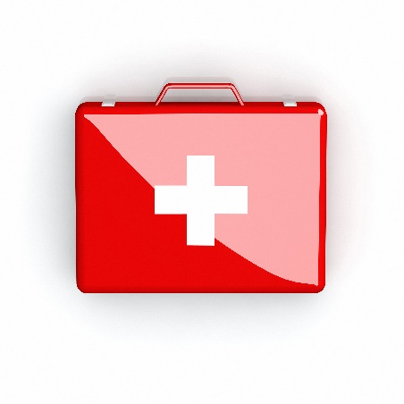 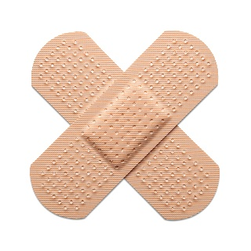
In the event of a life-threatening accident or condition, immediately dial 911. Do not assume that someone else has already called 911. If you are not personally aware of the call being made, call 911. It is better for there to be multiple 911 calls for the same incident than none at all.
Notify your manager or supervisor immediately in the case of any other accident or illness, even if it seems to be minor.
First aid kits are kept in various locations. It is your responsibility to familiarize yourself with the location of each of these. It is very important to protect yourself from the transfer of body fluids. Each first aid kit contains gloves and these should be used when assisting. A strong disinfectant should be used to clean up.
Supplies in the first aid kits are the property of the company and are solely provided for treatment of workplace injuries. Removal of first aid supplies for personal use is a violation of company policy and may inhibit the proper treatment of a workplace injury.
On the job injuries and accidents may be covered under Workers' Compensation. Additional first aid & emergency procedures are located in the Infectious Disease & Bloodborne Pathogen Manual & Bloodborne Pathogens, Exposure Control Manual.
To promote the safety and wellbeing of our employees, Central State has purchased Automated External Defibrillators (AEDs) at the Coleman Home. AEDs are only to be used in the event that a person is not breathing and has no pulse. They are potentially lifesaving but also potentially dangerous if used improperly. Central State has provided training to designated employees in the proper use and operation of the AED. In the event of an emergency a trained employee, if available, should operate the AED.

